Finsite Bank — Finance Analytics Dashboard
Power BI | DAX | Time Intelligence | Data Modeling | Dashboard Design
Project Report — Personal / Portfolio Project

1. Project Overview
This is an end-to-end Power BI finance analytics project built for a fictional bank, "Finsite Bank," covering the full workflow: data collection, cleaning, modeling, DAX measure design, and dashboard build-out. The project simulates a real banking transactions dataset spanning 2023-2026, scaled down from real-world volumes (transactions reduced at roughly a 1:100 ratio) while keeping the structure and patterns of genuine transaction data. It is built as two connected report pages: an Overview Analysis dashboard and a Transactions dashboard, using two related tables — a transactions table and a customers table — joined through data modeling.

2. Problem Statement / Objective
- Give banking stakeholders a single, interactive view of transaction volume, value, fees, and tax collected across years, regions, and customer segments.
- Show year-on-year (YoY) growth or decline for every core metric, using the currently selected year vs. the same period last year.
- Let users dynamically switch the underlying metric driving the charts (e.g., view any chart by Amount, Fees, Tax, or Transactions) instead of building separate charts for each.
- Support root-cause investigation through drill-through (e.g., drill into a specific month or a failed-transaction status) and let users export the underlying records to CSV.

3. Tools & Data Source
Tool: Microsoft Power BI Desktop — data modeling, DAX, and report design; planned publishing to Power BI Service and Microsoft Fabric
Data: A transactions table (Transaction ID, Amount, Fee Amount, Tax Amount, Transaction Date, Transaction Status, Transaction Type, Category, State) and a related customers table (customer segment, occupation, gender), spanning 2023-2026
Supporting table: A dedicated Calendar/Date table, related to the transactions table and used for all time-intelligence calculations

4. Data Modeling Approach
- Two fact/dimension-style tables — transactions and customers — connected through data modeling rather than kept as flat, disconnected data.
- A standalone Calendar table, related to the transactions table on the date field, so time-intelligence functions behave reliably instead of relying on transaction dates directly (which can have gaps).
- A global year filter (2023-2026) applied across the report; selecting a year automatically recalculates every YoY comparison against the prior year — e.g., 2026 has only Jan-Apr of data, so the YoY comparison correctly compares against the same four months of 2025, not a full year.

5. Key DAX Measures Built
For each of the 5 core KPIs, the same repeatable three-step DAX pattern was used: (1) a base measure, (2) a previous-year version using SAMEPERIODLASTYEAR() against the Calendar table, and (3) a YoY growth and YoY % measure comparing the two.
Measure | DAX Logic (in plain terms) | Business Purpose
Total Amount | SUM of transaction Amount | Overall transaction value for the period
Previous Year Amount | SAMEPERIODLASTYEAR() on the Calendar table | Baseline for year-on-year comparison
YoY Amount / YoY % | Current − Previous, then ÷ Previous | Growth or decline vs. last year
Total Transactions | DISTINCTCOUNT of Transaction ID | Number of transactions processed
Average Transaction Value | AVERAGE of Amount | Typical transaction size
Total Fees / Total Tax | SUM of Fee Amount / Tax Amount | Revenue and tax components tracked separately
Previous Year & YoY versions | Same SAMEPERIODLASTYEAR() pattern repeated | Consistent YoY view across every KPI

6. Dashboard Pages & Features
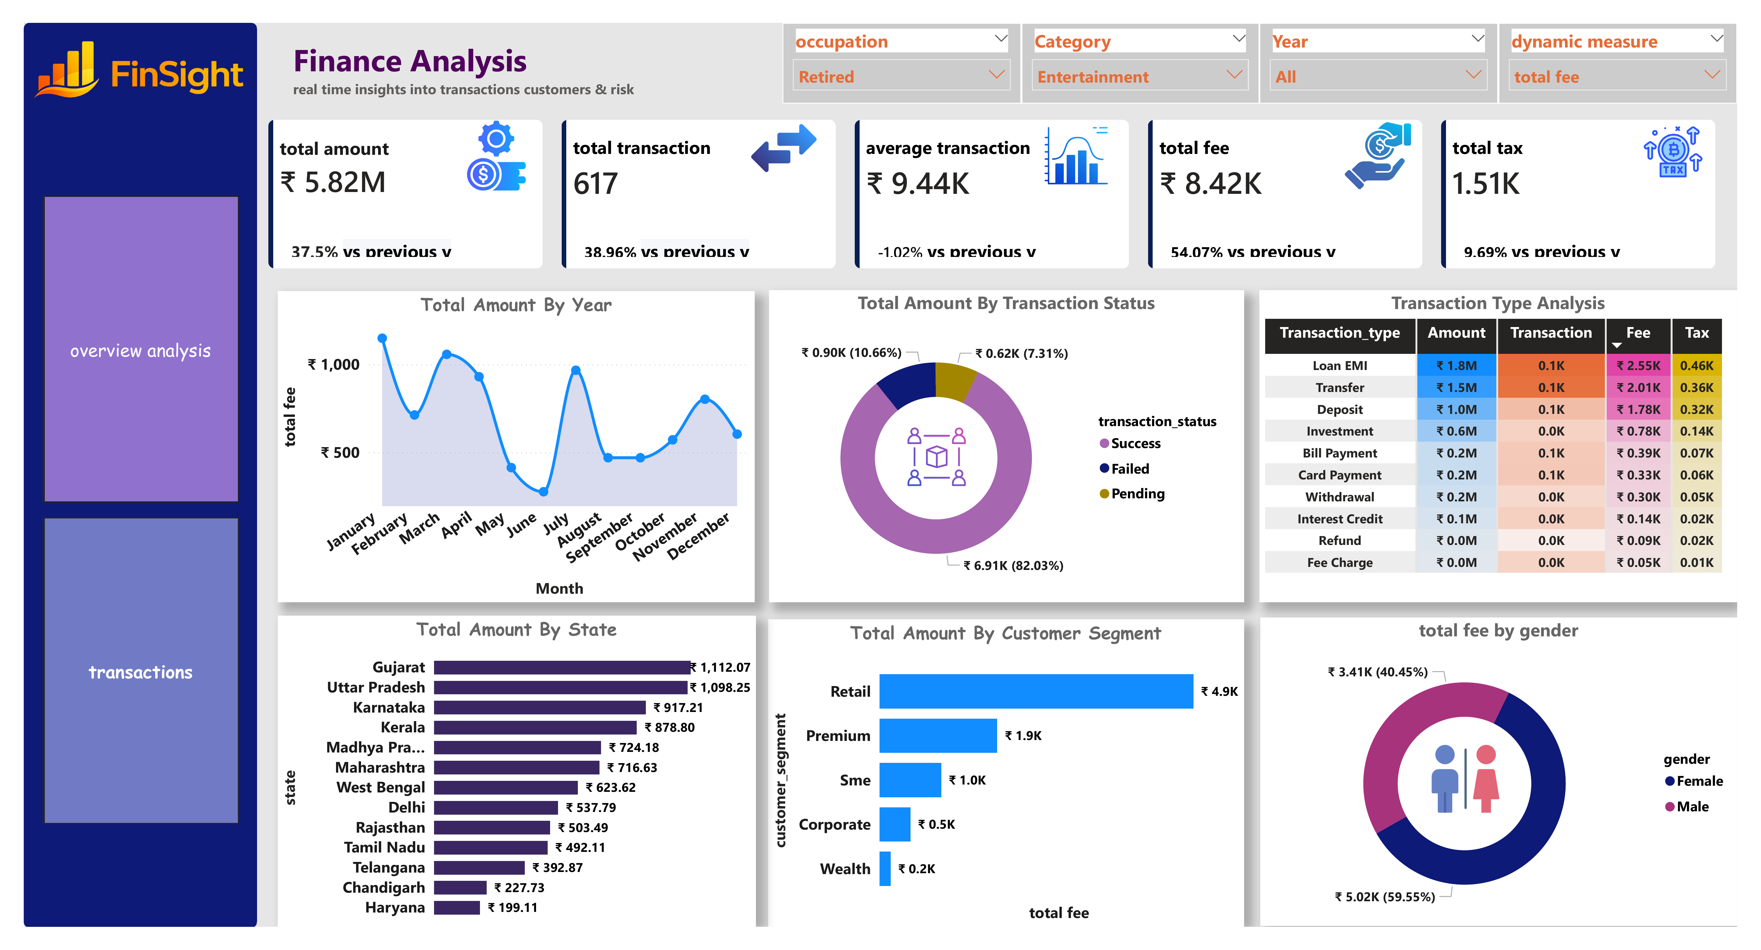
Figure 1: Overview Analysis dashboard — KPI cards, YoY trends, and regional/segment breakdowns

6.1 Overview Analysis dashboard
- 5 headline KPI cards (Total Amount, Total Transactions, Average Transaction Value, Total Fees, Total Tax), each with a secondary YoY badge showing growth/decline vs. the previous year.
- A dynamic measure selector that lets any chart be re-driven by a different metric (Amount, Fees, Tax, or Transactions) at runtime, instead of building one chart per metric.
- A set of drill-down charts for deeper analysis:
Chart | Type | Purpose
Amount by Month | Line / area (trend) | Spot seasonal spikes or drops across the year
Amount by Transaction Status | Donut chart | Compare successful vs. failed vs. pending transactions
Amount by Customer Segment | Horizontal bar | Identify the most valuable customer groups (retail, premium, corporate, wealth)
Amount by State | Bar / map | Regional performance (e.g., Maharashtra, Karnataka, Gujarat top states)
Amount by Transaction Type | Heatmap / color-coded table | See which transaction types (bill payment, EMI, transfer, etc.) drive the most volume
Amount by Gender | Bar / donut | Compare transaction behavior by gender

- Additional slicers for occupation (e.g., student, freelancer) and transaction category (e.g., fuel, food delivery, entertainment).

6.2 Transactions dashboard
- A detail-level view listing every individual transaction, built on the transactions and customers tables.
- Drill-through from Overview Analysis into this page — e.g., drilling from a specific month's data point shows every underlying transaction for that month/year; drilling from a chart segment (like "Failed" status) filters the detail view to only that segment.
- An export-to-CSV option (via the visual's "···" menu) so a filtered view — such as all failed transactions for further investigation, or all transactions for a specific state — can be handed off to another team.
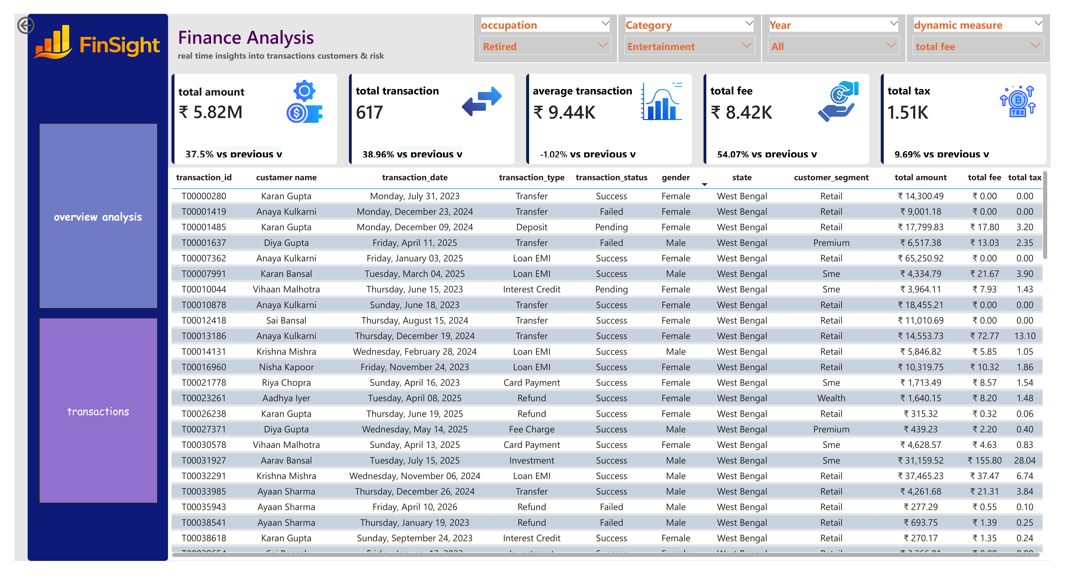
Figure 2: Transactions dashboard — detail-level transaction records with drill-through

7. Reference Label / Formatting Details (KPI layer)
- Used the Reference Labels / Reference Label Layout feature to attach a small, styled YoY badge under each headline number, labeled "vs previous year," with black text on a white background for readability.
- Applied Indian currency (₹) formatting on all monetary KPIs using the English (India) locale.
- Formatted YoY measures as percentages, and added custom icons next to each KPI card for a cleaner, more intuitive layout.

8. Skills Demonstrated
- DAX: CALCULATE, SUM, AVERAGE, DISTINCTCOUNT, DIVIDE, and the SAMEPERIODLASTYEAR() time-intelligence function
- Data modeling: relating multiple tables (transactions, customers, calendar) rather than working off a single flat table
- Dynamic/parameterized reporting: building charts that can be re-driven by different metrics at runtime
- Interactivity: drill-through navigation, filtered CSV export, and multi-level slicers (year, occupation, category)
- Report formatting: reference labels, locale-based number formatting, and visual polish with icons
- (Planned) Deployment: publishing to Power BI Service and Microsoft Fabric

9. How to Explain This Project in an Interview

Elevator pitch (30 seconds)
"I built an end-to-end Power BI finance analytics dashboard for a simulated bank, covering transaction volume, value, fees, and tax across 2023-2026. It has two pages — an executive Overview with 5 KPIs and year-on-year comparisons, and a Transactions detail page connected via drill-through. I modeled relationships between a transactions table, a customers table, and a dedicated date table, used DAX time-intelligence functions like SAMEPERIODLASTYEAR for YoY growth, and built dynamic charts that let users switch the underlying metric — like amount, fees, or tax — without duplicating visuals."

If asked: "Walk me through your approach"
- Started from documented business requirements: 5 core KPIs plus a secondary YoY KPI for each.
- Modeled the data: related the transactions table, customers table, and a Calendar table for reliable time intelligence.
- Built a repeatable 3-measure DAX pattern (current → previous year → YoY %) and applied it across all 5 KPIs.
- Designed the Overview page with KPI cards, dynamic charts, and slicers, then added a Transactions detail page with drill-through and CSV export.

If asked: "Why a separate Calendar table instead of using the transaction date directly?"
Because time-intelligence functions like SAMEPERIODLASTYEAR() need a continuous, unbroken list of dates to shift correctly — the transactions table only has dates where a transaction happened, which can have gaps. A dedicated date table avoids that and is a Power BI best practice.

If asked: "How did you handle a partial year like 2026?"
The YoY logic compares like-for-like periods — if only January-April 2026 exists, it's compared against January-April 2025, not the full prior year, so the growth percentage stays meaningful instead of being artificially skewed.

If asked: "What would you improve next?"
- Consolidate the repeated 3-measure DAX pattern into fewer, parameterized measures for easier maintenance.
- Add Row-Level Security if this were used by multiple regional finance teams.
- Automate refresh and publish the finished model to Power BI Service / Microsoft Fabric with a scheduled refresh.

10. Suggested Resume Bullet Points
- Built an end-to-end Power BI finance analytics dashboard for a simulated bank, tracking transaction volume, value, fees, and tax with year-on-year (YoY) trend tracking across 5 KPIs.
- Modeled relationships across transactions, customers, and a dedicated calendar table; applied DAX time-intelligence functions (SAMEPERIODLASTYEAR, CALCULATE, DIVIDE) to compute YoY growth.
- Designed a two-page dashboard (Overview + Transactions) with dynamic metric-switching charts, drill-through navigation, filtered CSV export, and locale-based currency formatting.

11. Status
This report reflects the project scope described in the tutorial intro plus the KPI/DAX build steps confirmed so far (all 5 KPI cards with YoY measures, reference-label formatting, currency formatting, and icons). The chart build steps (monthly trend, donut, bar, state, heatmap, gender charts), data modeling walkthrough, drill-through setup, export button, and publishing steps are part of the project's stated scope but not yet confirmed as built in this chat. Share the next parts of the transcript as you complete them and this report will be updated to match.

